**Chapter No. 8**

**User Guide**

**User** **Guide**

**8.1:** **Main Page of Institute**

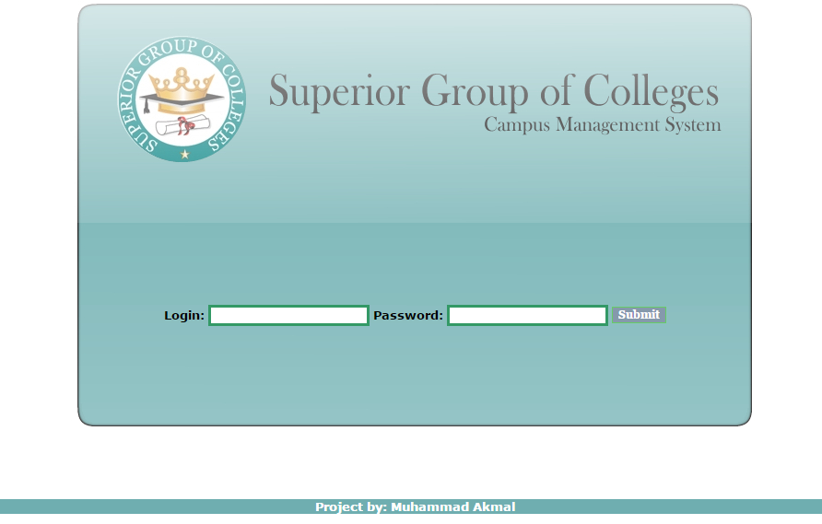

**8.2: Total Number of Classes**

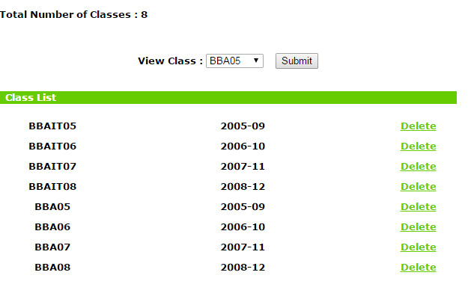

**8.3: Total Lectures**

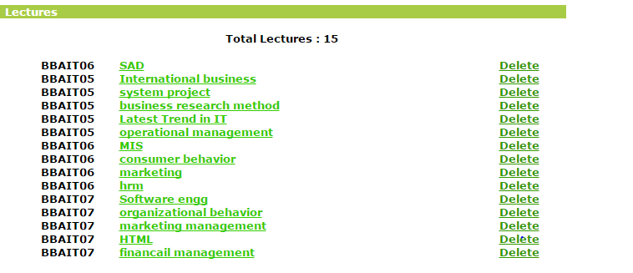

**8.4 Add New Classes**

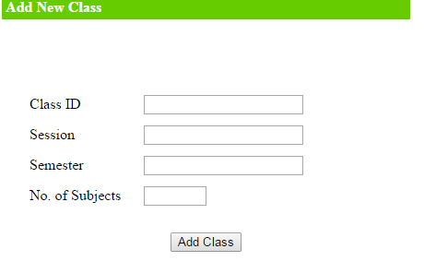

**8.5: Add Course**

